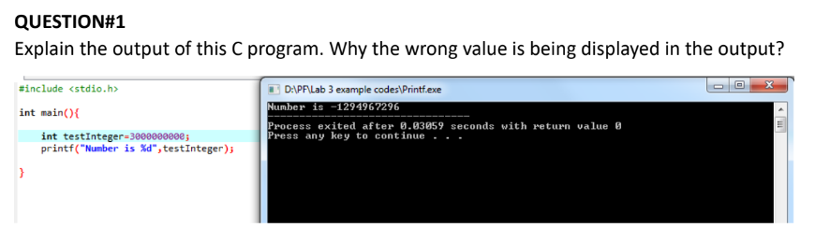

**Because default int type data is 32 bits meaning it can only store upto 2147483647 considering 3000000000 is a larger number than the limit causes overflowing leading to unexpected results.**